Outcome Testing
Solution Guide
Ascot Lloyd · known as OTIS in production
As of 2 October 2026
Author: Simunye Radingwana

What the solution is
Outcome Testing (called OTIS in production) is how Ascot Lloyd proves that the advice its advisers give is suitable. A sample of each adviser's client files is checked against a fixed checklist, graded, and, where a file fails, sent back to the adviser to fix, with every step recorded.
Before OTIS, this ran on Word documents, Excel trackers and email. That meant:
- nobody could easily see who was checking which file;
- there was no proof of which checklist a file was graded against;
- a regrade overwrote the original result, which is the record a regulator asks for;
- fixes (remediation) were chased by email with no clear closure.
OTIS replaces all of that with one database (Microsoft Dataverse) as the single source of truth, and two screens on top of it: one for managers and administrators, one for checkers and advisers. Every status change, grade and correction is stored and audited.

Who uses it
Nine roles use OTIS. Checkers, advisers and T&C Managers work in the portal; managers and administrators work in the management app. One person can hold more than one role.
Role | What they do | Where
AQS Checker | Picks up AQS (advice quality) checks from the queue, completes the checklist and gives the outcome | Portal
Tax Checker | Completes Tax checks allocated to them, then sends the case on to AQS or back to the paraplanner | Portal
AQS Team Manager | Allocates AQS checks to their team and watches workload | App
Tax Team Manager | Allocates Tax checks to their team and watches workload | App
Adviser | Sees failed checks on their own cases and records what they did to put things right | Portal
T&C Manager | Signs off the adviser's remediation (approve or reject) and records the final outcome | Portal
Paraplanner | Receives an email with a PDF of each completed check; no sign-in | Email
OTIS Manager | Oversees all cases and can allocate either type of check | App
Administrator | Imports cases, manages people and roles, maintains the checklist and settings, runs reports and exports | App and portal

Every signed-in portal user can read all cases, but can only act on work assigned to them. Regional managers receive notification emails only and have no sign-in.
Each role has its own plain-language PDF guide in docs/user-guides/.

How a case moves through OTIS
A case goes from import to closure along one fixed path. The server refuses any status change that is not on it.
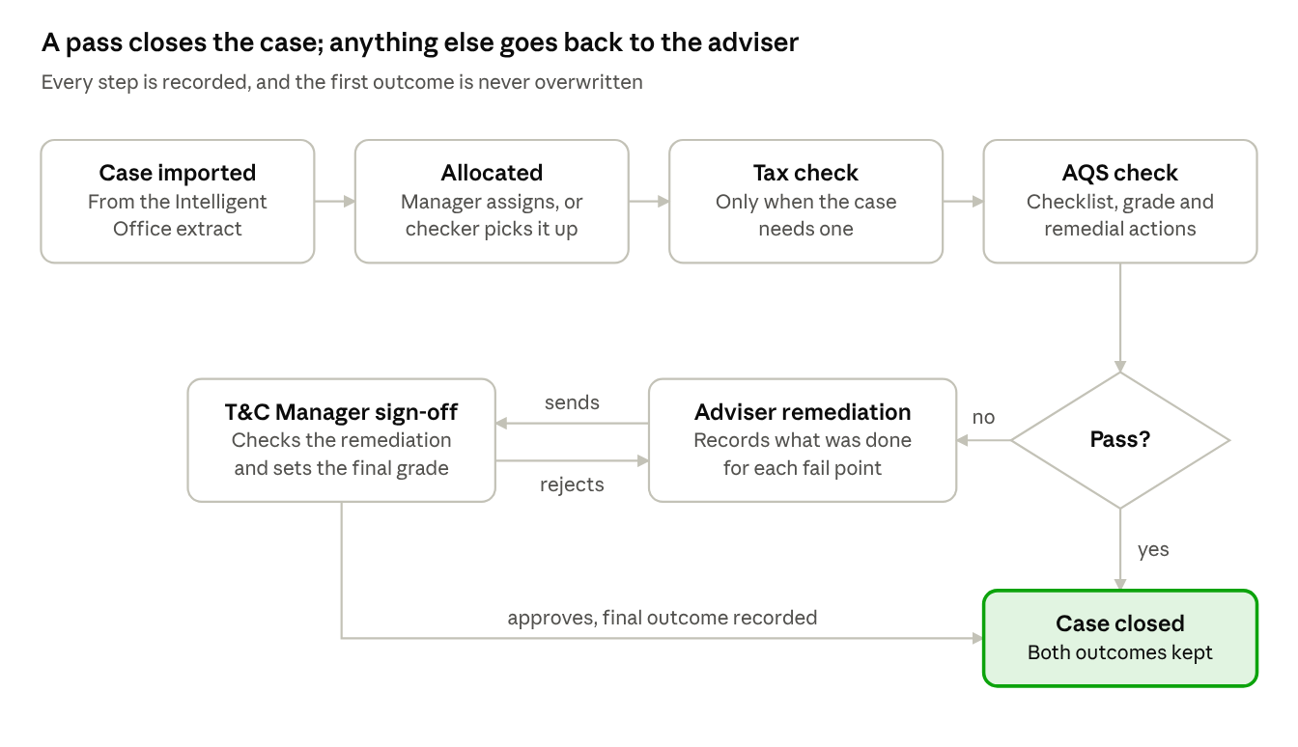
Figure 1. The case journey
A pass closes the case straight away. Any other grade sends the case to the adviser, and a rejected sign-off loops back to them with notes. A Tax checker can also return a case to the paraplanner, which ends it at the Tax check.

Emails along the way
- The checker is emailed when a case is allocated to them.
- The paraplanner is emailed a PDF of each completed check.
- The adviser is emailed when remediation is needed, and again if it is rejected.
- The T&C Manager is emailed when an adviser sends remediation for sign-off.

The building blocks
OTIS is built entirely on Microsoft Power Platform. Two front ends sit on one database, and all business logic runs once, on the server.
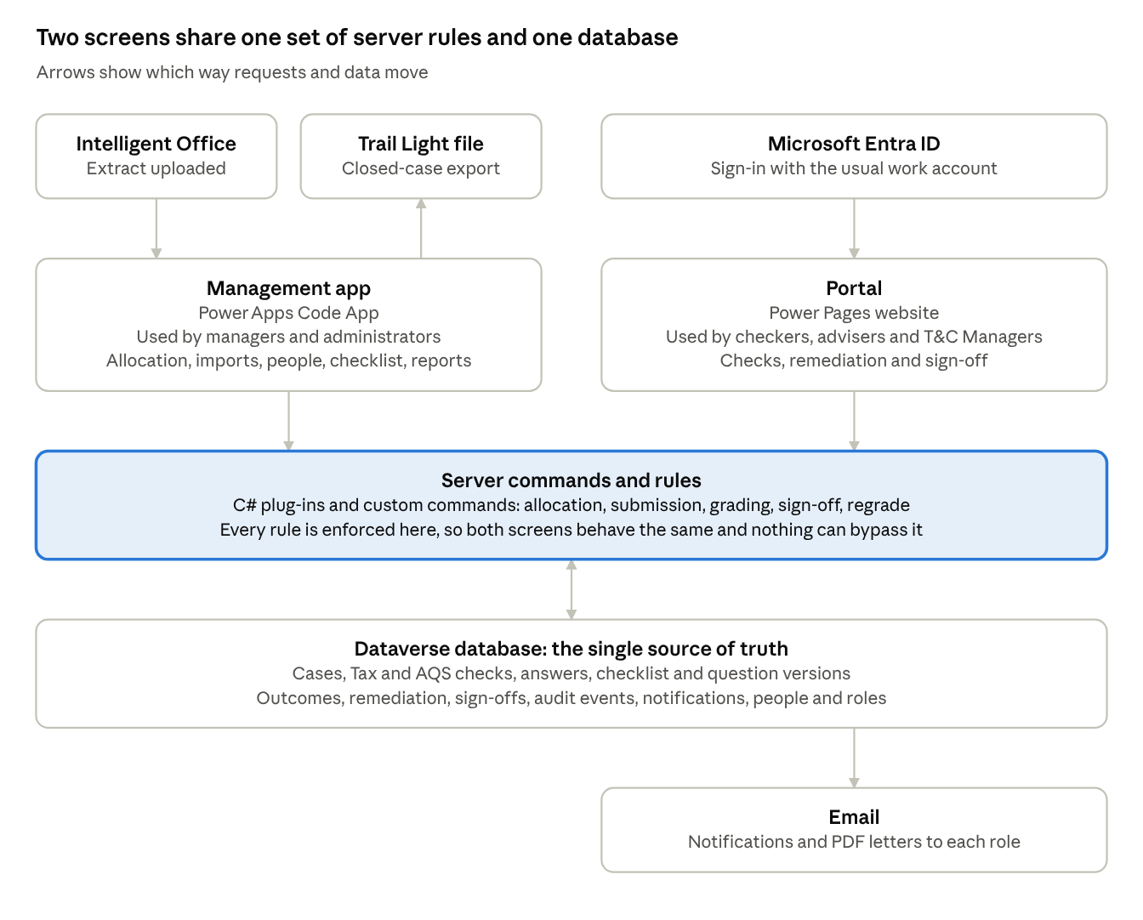
Figure 2. How the parts fit together
Part | What it does
Management app | The managers' and administrators' screen: dashboard, case worklist, allocation, case intake, reporting, Trail Light export, question library, adviser mapping, email wording, dropdown options, security and people
Portal | The working screen for checkers, advisers and T&C Managers: queues, the checklist, remediation and sign-off. Every page checks the signed-in person's role
Server commands and rules | Each action (allocate, submit, sign off, regrade, import) is a server command. Plug-ins check every write, so a rule cannot be skipped from either screen
Dataverse | Stores everything as linked records: a case holds its checks, each check holds its answers, and each answer points to the exact question version used
Email | Notifications are queued as records, then sent as emails, with PDFs of completed checks attached

Client documents are not copied into OTIS. They stay in Intelligent Office and are referenced from the case.

Key rules
These rules are enforced on the server, so they apply the same way whichever screen is used.

Routing and allocation
- A case needs a Tax check, an AQS check, or both. When it needs both, Tax goes first.
- Allocation is manual. A team manager assigns a case, or an AQS checker picks one up from the queue. There is no automatic routing.
- Tax and AQS team managers can only allocate within their own team, and only to people who hold the matching checker role.
- Moving a case to another checker keeps the work already done.

Checklist and grading
- Checks use the Checker Checklist (version 8), split into sections of questions.
- Questions and sections are never deleted. They are dated in and out, and a submitted check always reads as it did on the day it was submitted.
- The AQS grade is one of Pass, Pass with issues, Insufficient evidence or Potential harm. Any grade other than Pass needs a root cause.
- A check cannot be submitted until every required question is answered and every fail point has a remedial action.

Remediation and sign-off
- A non-pass outcome creates remediation for the adviser, but only once every check on the case is finished.
- The adviser records whether each action was performed, then sends it to their T&C Manager.
- Sign-off needs the adviser to be mapped to a T&C Manager. Without that mapping, sign-off is refused.
- The T&C Manager approves (and records the final outcome) or rejects with notes, which sends it back to the adviser.

Outcomes and history
- Both the initial and the final outcome are kept. A regrade never overwrites the original.
- A closed case cannot be edited. Correcting an outcome is a T&C Manager action that needs a reason, and it is recorded in the audit log.
- Case statuses can only move forward along the allowed path. Closed and No Check Required are final.

Emails and exports
- All notifications are by email. Administrators can edit the wording in the app.
- The Trail Light export is produced by hand, on demand, from closed cases. A Tax-only case is exported with its File Quality and Advice Quality columns blank, because those come from the AQS check.

Environments and releasing changes
There are three environments. Changes are built in DEV and move forward only as a packaged, managed solution.
Environment | Purpose | Name shown to users
DEV (Env_AQ_Dev) | All building and first testing | Outcome Testing
TEST (Env_AQ_Test) | User acceptance testing on a managed copy | Outcome Testing
PROD | Live use; portal at otis-ascotlloyd.powerappsportals.com | OTIS

The product name is one setting per environment, so the same package says "Outcome Testing" in DEV and TEST and "OTIS" in PROD.

How a release moves
- Build and test in DEV: plug-ins, the management app and portal pages.
- Export the OutcomeTesting solution as a managed package. It carries the tables, plug-ins, server commands, security roles, the management app and the portal pages together.
- For PROD only, rebrand the package to OTIS with the registration tool's brandpackage command.
- Import with scripts/Import-Solution.ps1. It always switches the plug-in steps on and checks they are running, because an import without that silently disables the server-side rules.
- Read the solution version back from the target to confirm the import really happened.
- Copy configuration data separately (dropdown options, email wording, adviser mappings). It is data, not part of the solution.
Set by hand in each environment, never shipped: the portal's web address, its Entra sign-in, and the product name.
PROD runs version 1.0.18.0, installed on 1 October 2026. Still to do before go-live: approve the sending mailbox, share the management app, set site access, and run one real case end to end. Every PROD change is approved and carried out by the system owner.

Running it day to day
Most routine work is done by administrators in the management app.
How often | Task
Daily | Upload the Intelligent Office extract and resolve rows that failed the checks. Look for cases waiting too long for allocation, and for overdue remediation.
When people join, move or leave | Update their roles on the People page and keep the adviser-to-T&C Manager mapping current.
When the checklist changes | Date questions or sections in or out in the Question library.
As needed | Reallocate cases, correct case details, run reports, produce the Trail Light export.

Giving someone access
- Grant them access to the portal site (Power Pages, Site visibility). Using one Entra group for this is easiest.
- Make sure they exist as a person (contact) with their work email, and that their sign-in is linked. For many people at once, the registration tool's onboardpeople command does this from a people file.
- Give them their roles on the People page.
- If they are an adviser, map them to their T&C Manager.

Common problems
What people see | Usual cause | Fix
"You don't have access to this site" | Not on the portal's site access list | Add them in Site visibility (step 1 above)
Signs in but sees an empty portal | No portal role | Grant a role on the People page
Sign-off is refused | Adviser not mapped to a T&C Manager | Add the adviser mapping
A case cannot be allocated to someone | The person has no OTIS role, or the wrong checker role | Grant the matching checker role
Error mentioning a privilege check in the app | Their role is missing the base user access | Add the Basic User security role alongside the OTIS role
An email shows "Sent" but never arrived | "Sent" means queued, not delivered | Check the email record's delivery status
A portal page still shows old data after a change | Portal cache | Wait for the cache, or clear it from the portal admin

Testing access with an administrator account proves nothing: administrators bypass the site access list. Always test with an ordinary account.

Where to find more
Everything lives in the OutcomeTesting repository.
Folder | What is in it
src/ | The Dataverse solution: tables, security roles, server commands, plug-in registration and portal components
plugins/ | The server-side rules (C#), their tests, and the registration tool used for setup and support tasks
app/ | The management app (React and TypeScript)
powerpages/ | The portal's pages, templates and settings
scripts/ | Import and portal deployment scripts
docs/user-guides/ | One plain-language PDF guide per role
docs/deployment/ | A dated record of every change deployed, and how it was checked
docs/reference/ | The business requirements, the checker checklist and the portal access runbook
knowledge/ | Domain context, requirements index and the full decision log

